Action Templates
The action templates section of your settings menu is where you can create and edit email or SMS templates.
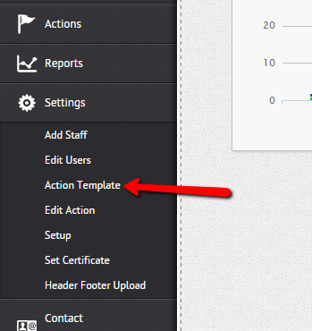
Once inside the action template section, the top part of the page includes a section for creating new templates.
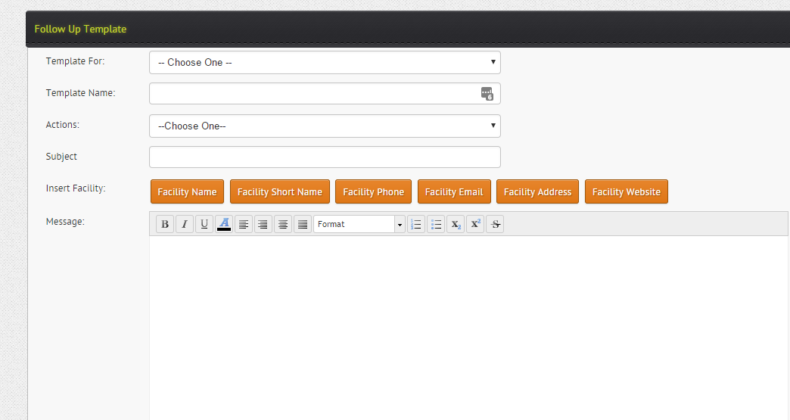

Within this section you can choose what the template is for, name the template, determine the action type, the subject and finally the content of the email.
There are multiple action types.
The core ones include
Email- This is an email template that will be manually sent as part of an action. Typically a non progression or progression assessment email.
Auto email- This is an email you wish to be sent automatically. For example a welcome email or class details email.
Auto SMS- This is an SMS that is sent automatically such as a class details SMS
General email template- This is a general email template that you may edit before sending as a bulk email.
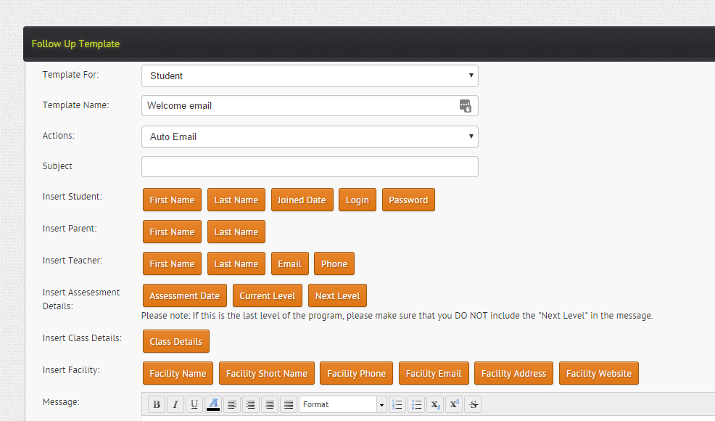
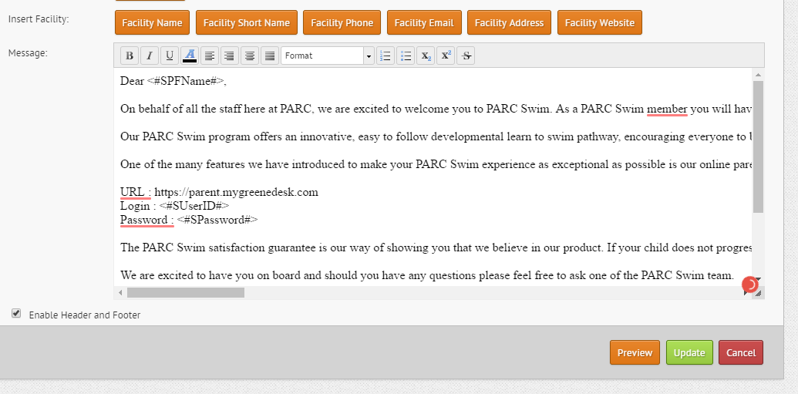
You can build your email template by writing your email content in the message section.
To further personalise the template you may wish to use the embedded fields feature.
Embedded data fields
Embedded data fields allow you to personalise an email from a template by automatically putting personalised information such as the name of the parent, name of the child, login, password or class details.
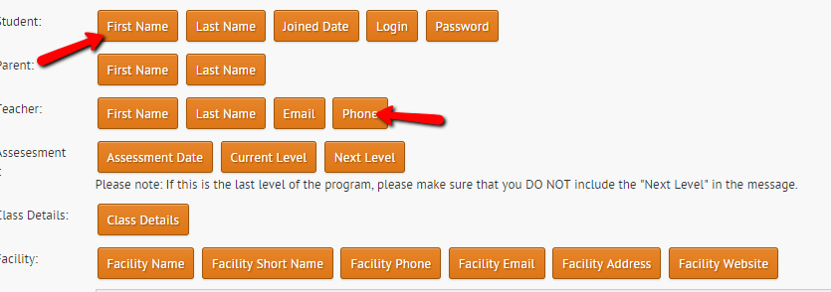
You can add embedded fields to the email template simply by clicking the orange embedded field button as shown above.

Template library
Directly below the template creation section is a library of existing templates. You can easily edit these templates via the edit template button.
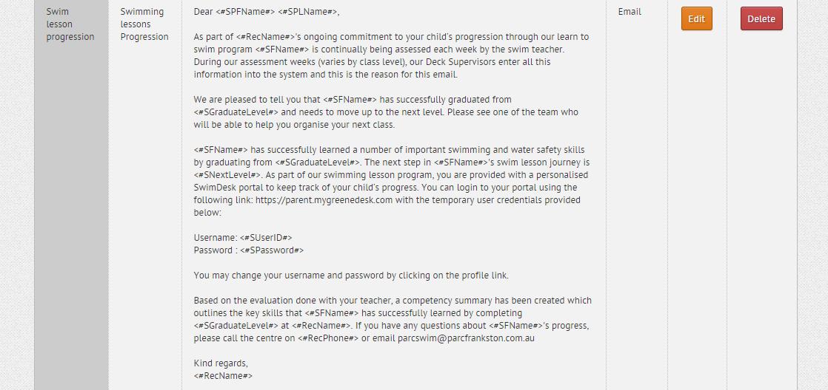
Editing templates
You can easily edit your templates by clicking the edit button.
This will open up the template within the creation section, where you can make changes before saving the template again.
If an automated action is set up for the template, any changes to the template will automatically take effect for that existing action.
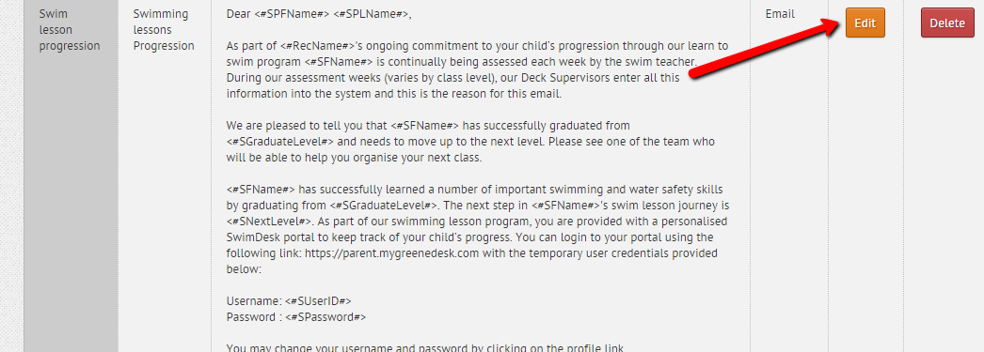

Email Header/Footer
You may want your email template to be sent with a header and footer. You can upload a header and footer image file via the header/footer section in your settings. If you have added a header footer you can enable a header/footer for each template via checking the box at the bottom of the template creator.
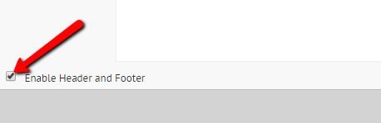
HTML template compatibility
Our email templates are also HTML compatible. This means that you can use HTML email designs within the templates. This allows you to have fully HTML branded with hyper linked images directing to various websites etc.

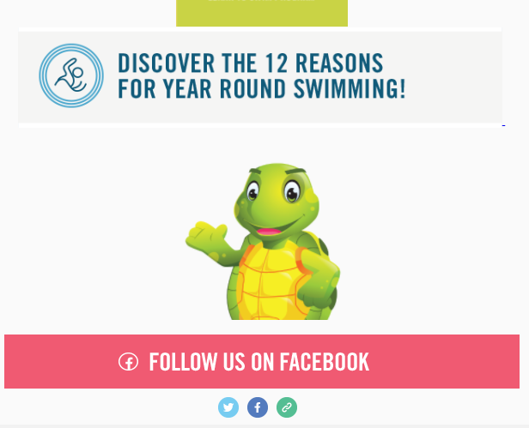

Scheduling Actions
Once you have created an action template (email or SMS) you can set up actions to schedule those communications. Actions typically are automated, however can also be linked to a manual event such as a progress or non-progressed assessment email.
To set up actions go to settings and select edit action
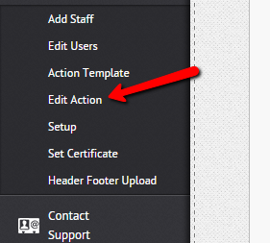
Within the action rules section, you will find a table containing existing rules. Here you can edit the parameters for existing rules, turn them on or off or delete the rule.
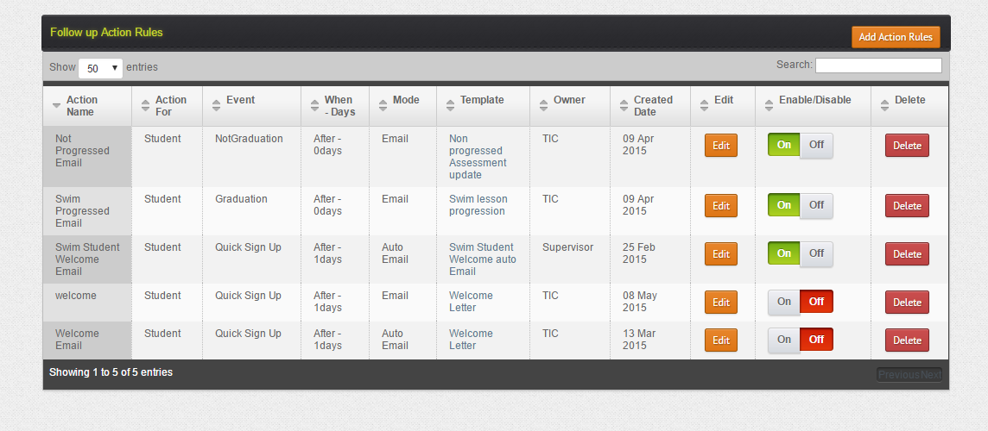

Adding New Actions
To create a brand-new action rule simply click the add action rules button.
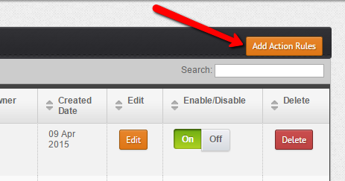
Within the action rule section simply follow the prompts. You will be required to select options for the name of the action, mode, owner, days, trigger and template.
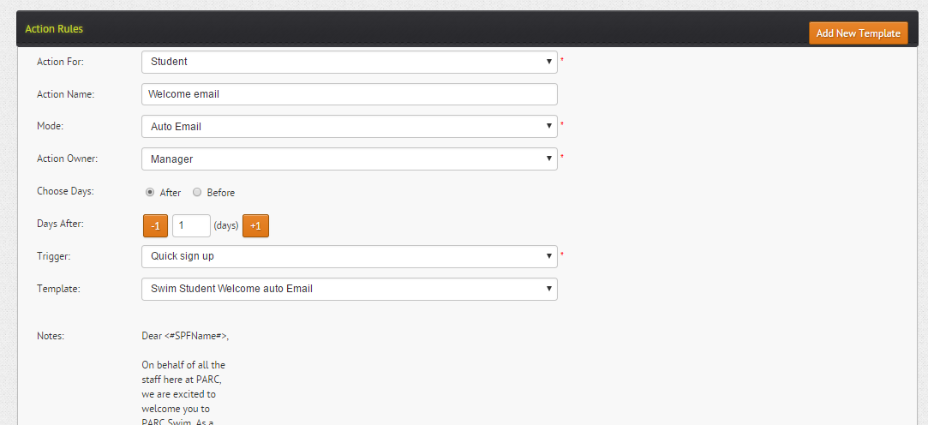
For example, if you wanted to set up a welcome email the set up would be as follows…..
Action for: Student
Action name: Welcome email
Mode: Auto email:
Owner: Manager
Days: After 1
Trigger: Quick sign up
Template: Choose the template you created for welcome email
Once you save an action ensure it is turned on and then whenever the criteria is met the action will be triggered.

